ETD2017 Symposium Sponsorship Opportunities
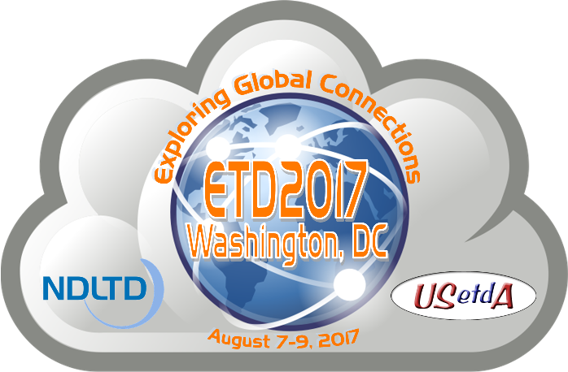
ETD2017, the 20th international symposium on electronic theses and dissertations will be held August 7 – 9, 2017 at the Embassy Suites by Hilton Hotel in Washington, D.C. The conference will be hosted by George Mason University with additional support from the Washington Research Library Consortium and co-organized by the Networked Digital Library of Theses and Dissertations (NDLTD) and the United States Electronic Thesis and Dissertation Association (USETDA). The theme for the ETD2017 Symposium is “Exploring Global Connections”.
Sponsorship Options
The ETD2017 Symposium offers a variety of sponsorship options to help support our mission as well as to promote your brands, products and services. You will find the ETD2017 Symposium sponsorship options and contract listed below, as well as online. Please take a few moments to consider which level of support you could offer and the value of the benefits we provide. Sponsors are welcome to submit a research-based presentation for consideration in the Call for Proposals (not intended for product demonstrations). Responses to this sponsorship invitation should be sent no later than March 15, 2017.
About ETD2017
The ETD2017 Symposium is an international conference for ETD faculty and professionals from all areas: graduate schools, libraries, and information technology specialists. Our goal is to offer relevant, practice-oriented content to support ETD productivity improvement, ETD professionals, advance ETD operations and encourage the formation of regional ETD associations and networking communities, to promote open access in scholarly communications as well as to provide useful and innovative resources, standards, and technology for the development and support of ETD programs.
We anticipate at least 150 people will attend from many countries around the world. In past years we have averaged 150 - 200 participants attending the annual conference. Together the NDLTD and USETDA serve constituents at thousands of colleges and universities worldwide. We have had numerous corporate and non-profit sponsors, (USETDA 2016 Conference, ETD2016 Symposium, ETD2015 Symposium) including colleges and universities, institutional repository and archival system providers, digital technology applications companies, bookbinders and other library related service providers.
A major component of the conference includes a Technology Fair where vendors can set up exhibits and interact with our audience. Additionally there are opportunities to participate in the conference during plenary and breakout sessions as well as through advertising and distribution of your promotional materials at the venue and online. We offer a variety of accommodations to suit your promotional needs.
Travel scholarship endowment - the NDLTD and USETDA are committed to hosting an inclusive event, thus we are soliciting donors to support travel scholarships for ETD professionals from developing nations who wish to attend the ETD2017 Symposium. We encourage all sponsors to contribute generously to help those in need.
ETD Symposia are a fantastic venue for you to reach out to your constituents worldwide. Please consider showing your support by sponsoring this important event.
Contact Person:
John H. Hagen, Executive Director
Email: john.hagen@renaissance-scholar.com
www.usetda.org
Sponsorship Contract: See next page

ETD2017 Symposium Resources:
- ETD2017 Symposium Information http://www.usetda.org/usetda-conferences/etd2017/
- ETD2017 Symposium Sponsorship Online Payment www.usetda.org/membership/#B

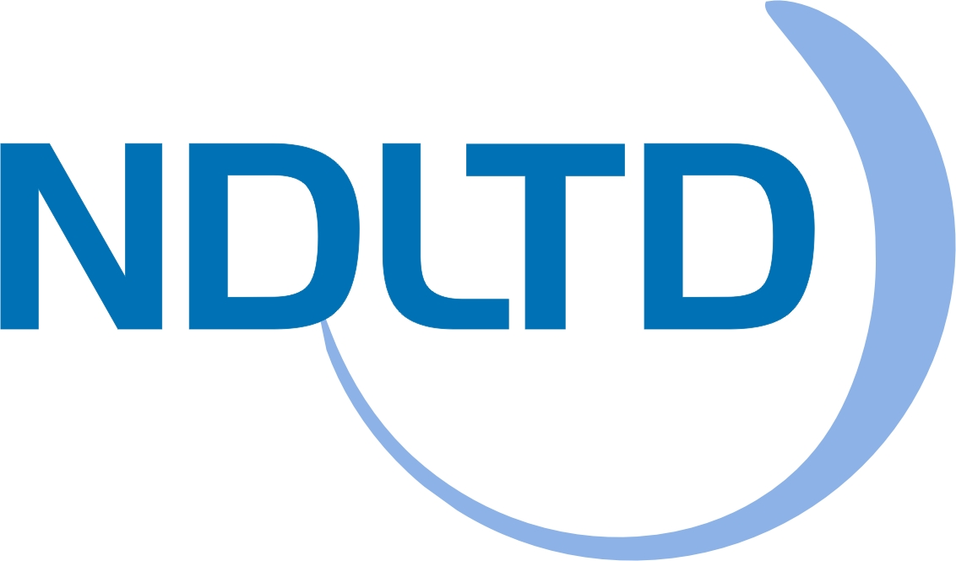

ETD2017 Symposium Sponsorship Contract

Questions? Contact John Hagen at john.hagen@renaissance-scholar.com / (304) 290-2516

SPONSORSHIP CONTRACT between NDLTD / USETDA International Symposium on Electronic Theses and Dissertations and
Sponsoring Organization’s Name & Address

$

The sponsor brings to the International Symposium on Electronic Theses and Dissertations, ETD2017, a contribution of

U.S. Dollars, corresponding to the following sponsorship level:

Platinum Sponsor $10,000
- Logo depicted on the front cover of the Conference program
- Mention in all conference literature as a Major sponsor
- Logo displayed on the Conference Web site*
- One full-page color advertisement in the Conference Program (camera ready, 7.5 inches wide by 10 inches high)
- Two-table display in the conference exhibition area
- Presentation from the sponsor (20 minutes) during a plenary session**
- Welcome address at the conference reception
- Opportunity to include leaflets in conference delegate packs
- Five complimentary conference registrations for representatives

Gold Sponsor $5,000
- Logo depicted in the Conference program
- Mention in all Conference literature as an Associated Sponsor
- Logo displayed on the Conference Web site*
- Half-page color advertisement in the Conference Program (camera ready, 7.5 inches wide by 5 inches high)
- Two-table display in the conference exhibition area
- Welcome message at a conference lunch
- Opportunity to include leaflets in conference delegate packs
- Three complimentary conference registrations for representatives

Silver Sponsor $2,500
- Logo depicted in the Conference program
- Mention in all Conference literature as an Affiliated Sponsor
- Logo displayed on the Conference Web site*
- Quarter-page color advertisement in the Conference Program (camera ready, 3.75 inches wide by 5 inches high)
- Full-table display in the conference exhibition area
- Welcome message at a conference breakfast
- Opportunity to include a leaflet in conference delegate packs
- Two complimentary conference registrations for representatives

Bronze Sponsor $1,500
- Logo depicted in the Conference program
- Mention in all Conference literature as an Affiliated Sponsor
- Logo displayed on the Conference Web site*
- Quarter-page color advertisement in the Conference Program (camera ready, 3.75 inches wide by 5 inches high)
- Full-table display in the conference exhibition area
- Welcome message at a conference breakfast
- Opportunity to include a leaflet in conference delegate packs
- One complimentary conference registration for a representative

Partner Sponsor $1,000
- Logo depicted in the Conference program
- Mention in all Conference literature as a Sponsor
- Logo displayed on the Conference Web site*
- Quarter-page color advertisement in the Conference Program (camera ready, 3.75 inches wide by 5 inches high)

Travel Scholarship Endowment Sponsor $500 - $5,000
- Logo depicted in the Conference program

Membership – Bonus Benefit
- All sponsors receive a one-year NDLTD and USETDA membership

Regular Conference Registration Rates
- Developing Nations: $99 / Non-Developing Nations: $299

*Indicates the website will stay online after the event.

**Sponsor presentation guidance http://www.usetda.org/

Sponsorship Payment Processing Instructions:

This contract document will serve as the invoice for your sponsorship. Please complete, sign, scan/email or fax to return this contract to John Hagen, USETDA Executive Officer. We can also send a separate invoice document upon request. Payment may be made by check made payable to USETDA; include a copy of this contract with your check remittance. For online registration and credit card payments visit www.usetda.org/membership/#B.

NDLTD and USETDA are registered 501(c)(3) nonprofit charitable organizations. USETDA FEIN: 45-2743803

ETD2017 Symposium Sponsorship Contact Information:

USETDA

c/o John H. Hagen

545 W Herring Rd.

Masontown, WV 26542

Phone: (304) 290-2516

Email: john.hagen@renaissance-scholar.com

In return for sponsorship, we will give the sponsor the benefits associated with the sponsorship level or negotiated benefits as noted.

 | Sponsor Representative | ETD2017 Representative

Name

Title

Signature

Date

USETDA – United States Electronic Thesis & Dissertation Association

c/o John Hagen / Renaissance Scholarly Communications

545 W Herring Rd., Masontown, WV 26542 • Phone: (304) 290-2516

www.usetda.org/

