USETDA 2014 Sponsorship Opportunities
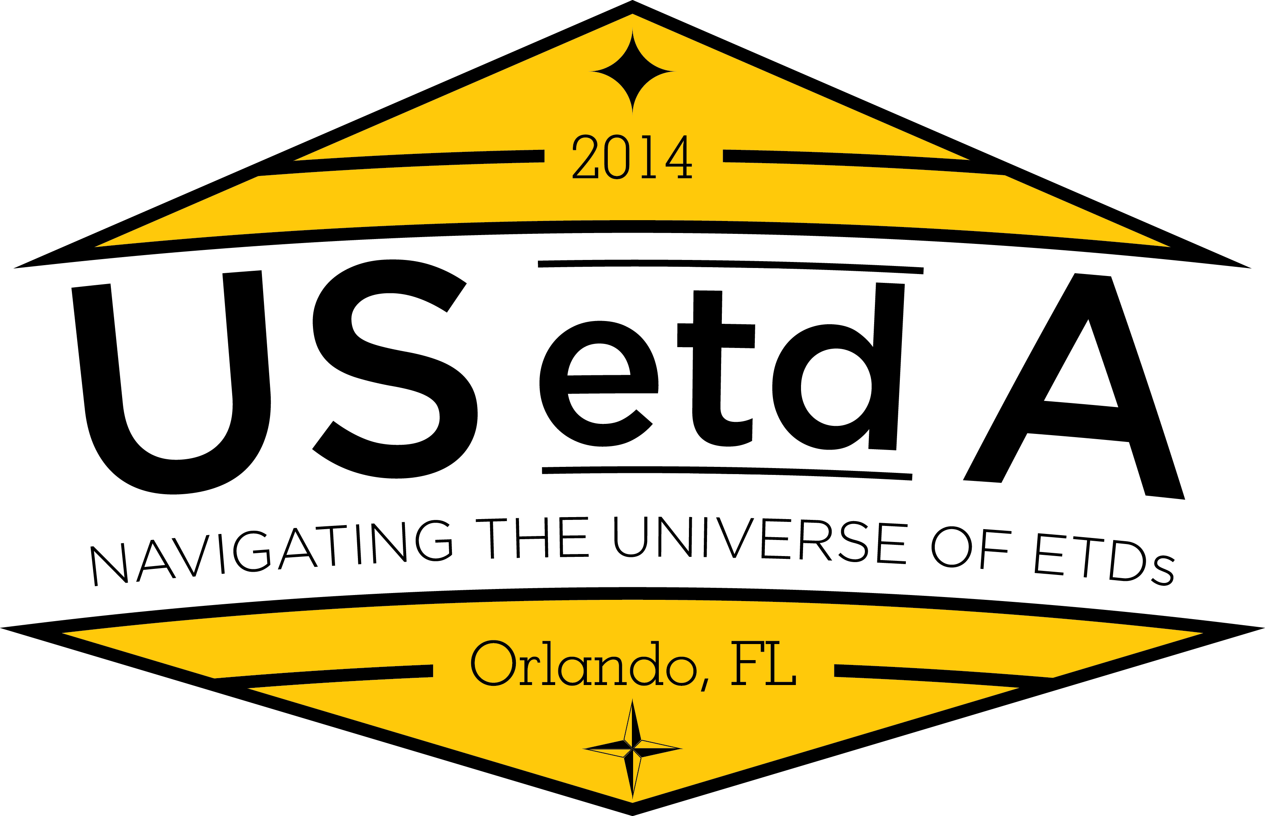
The United States Electronic Thesis and Dissertation Association (USETDA) has announced its 4th annual conference to be held September 24-26, 2014, at the Rosen Plaza Hotel in Orlando, Florida. USETDA 2014 is for professionals from graduate schools, libraries, academic computing and anyone else working with electronic theses and dissertations. Our goal is to offer relevant, practice-oriented content to support ETD professionals, advance ETD operations and efficiencies, and encourage the formation of state-wide ETD associations in the United States.
Sponsorship Options
The USETDA offers a variety of conference sponsorship options to help support our mission as well as to promote your brands, products and services. You will find the USETDA 2014 Conference sponsorship options and contract listed below, as well as online. Please take a few moments to consider which level of support you could offer and the benefits we provide. Sponsors are welcome to submit a research-based program for consideration in the Call for Proposals (not intended for product demonstrations). Responses to this sponsorship invitation should be sent no later than March 14, 2014.
About USETDA 2014
USETDA 2014 is the national conference for ETD professionals from all areas: graduate schools, libraries, and information technology specialists. Our focus is on relevant and current issues with an emphasis on sharing practice-based resources from around the U.S. We anticipate at least 100 people will attend, with most constituents being from the United States. In past years we have averaged 100 participants attending and had numerous corporate and non-profit sponsors, including colleges and universities, institutional repository and archival system providers, digital technology applications companies, bookbinders and other library related services. Part of the conference is the ETD Technology Fair, where vendors can set up exhibits and interact with our audience. Additionally there are opportunities to participate in the conference during plenary and breakout sessions as well as through advertising and distribution of your promotional materials at the venue and online. We offer a variety of accommodations to suit your promotional needs.
USETDA 2014 presentation topics will include:
- Services and outreach to enhance ETD development
- Supporting ETDs with Library services and information instruction
- ETDs and Ethics, Security & Quality
- Centralized and Decentralized submission processes
- Intellectual Property, Copyright, Patents and Tech Transfer
- Developing and implementing ETD Policies and Procedures
- ETD Innovation and Exploration
- File-types and Formatting, including issues surrounding non-traditional formats
- Publishing, Research and Data curation
- Nuts and bolts of ETD management including case studies of workflow and ingest models
- Retroactive digitization and ETD migration/harvesting
- Undergraduate and other student scholarship
USETDA conferences are a fantastic venue for you to reach out to your constituents. Please consider showing your support by sponsoring this important event.
Contact Persons:
John H. Hagen, Executive Officer
www.usetda.org

USETDA 2014 Conference Resources:
- USETDA 2014 Conference Information http://www.usetda.org/?page_id=2564
- Download USETDA 2014 Sponsorship Options
- USETDA 2014 Conference Registration / Sponsorship Online Payment http://www.usetda.org/?page_id=281

USETDA 2014 Conference Sponsorship Contract

Questions? Contact John Hagen at john.hagen@renaissance-scholar.com / (304) 290-2516

SPONSORSHIP CONTRACT between USETDA, U.S. National Conference on Electronic Theses and Dissertations and
Sponsoring Organization’s Name & Address

$

The sponsor brings to the U.S. National Conference on Electronic Theses and Dissertations, USETDA 2014, a contribution of

U.S. Dollars, corresponding to the following sponsorship level:

Platinum Sponsor $5,000
- Logo depicted on the front cover of the Conference program
- Mention in all conference literature as a Major sponsor
- Logo displayed on the USETDA Conference Web site*
- One full-page color advertisement in the Conference Program (camera ready, 7.5 inches wide by 10 inches high)
- Three complimentary conference registrations for representatives
- Full-table display in the conference exhibition area
- Presentation from the sponsor (20 minutes) during a plenary session**
- Welcome address at the conference reception
- Opportunity to include leaflets in conference delegate packs

Gold Sponsor $2,000 (vendor)
- Logo depicted in the Conference program
- Mention in all Conference literature as an Associated Sponsor
- Logo displayed on USETDA Conference Web site*
- Half-page color advertisement in the Conference Program (camera ready, 7.5 inches wide by 5 inches high)
- Full-table display in the conference exhibition area
- Welcome message at a conference lunch
- Two complimentary conference registration for representatives
- Opportunity to include leaflets in conference delegate packs

Gold Sponsor $2,000 (university / non-vendor)
- Logo depicted in the Conference program
- Mention in all Conference literature as an Associated Sponsor
- Logo displayed on USETDA Conference Web site*
- Half-page color advertisement in the Conference Program (camera ready, 7.5 inches wide by 5 inches high)
- Welcome message at a conference lunch
- Two complimentary conference registration for representatives
- Opportunity to include leaflets in conference delegate packs

Silver Sponsor $1,000 (vendor)
- Logo depicted in the Conference program
- Mention in all Conference literature as an Affiliated Sponsor
- Logo displayed on USETDA Conference Web site*
- Quarter-page color advertisement in the Conference Program (camera ready, 3.75 inches wide by 5 inches high)
- Half-table display in the conference exhibition area
- Welcome message at a conference breakfast
- One complimentary conference registration for a representative

Silver Sponsor $1,000 (university / non-vendor)
- Logo depicted in the Conference program
- Mention in all Conference literature as an Affiliated Sponsor
- Logo displayed on USETDA Conference Web site*
- Quarter-page color advertisement in the Conference Program (camera ready, 3.75 inches wide by 5 inches high)
- Welcome message at a conference breakfast
- One complimentary conference registration for a representative

Bronze Sponsor $750
- Logo depicted in the Conference program
- Mention in all Conference literature as an Affiliated Sponsor
- Logo displayed on USETDA Conference Web site*
- Quarter-page color advertisement in the Conference Program (camera ready, 3.75 inches wide by 5 inches high)

Conference Admission Rates
- Members: TBA
- Non-Members: TBA

*Indicates the website will stay online after the event.

**Sponsor presentation guidance http://www.usetda.org/?page_id=2748

Sponsorship Payment Processing Instructions:

This contract document will serve as the invoice for your sponsorship. Please complete, sign, scan/email or fax to return this contract to John Hagen, USETDA Executive Officer. Payment may be made by check made payable to USETDA; include a copy of this contract with your check remittance. For online registration and credit card payments visit http://www.usetda.org/.

USETDA is a national non-profit charitable organization, founded in 2009.

USETDA FEIN: 45-2743803

USETDA Conference Sponsorship Contact Information:

USETDA

c/o John H. Hagen / Renaissance Scholarly Communications

1121 Louise Avenue

Morgantown, WV 26505

Phone/Fax: (304) 290-2516

Email: john.hagen@renaissance-scholar.com

In return sponsorship, USETDA will give the sponsor the benefits associated with the sponsorship level or negotiated benefits as noted.

 | Sponsor Representative | USETDA Representative

Name

Title

Signature

Date

USETDA – United States Electronic Thesis & Dissertation Association

c/o Renaissance Scholarly Communications

Morgantown, WV • Phone/Fax: (304) 290-2516

www.usetda.org/

