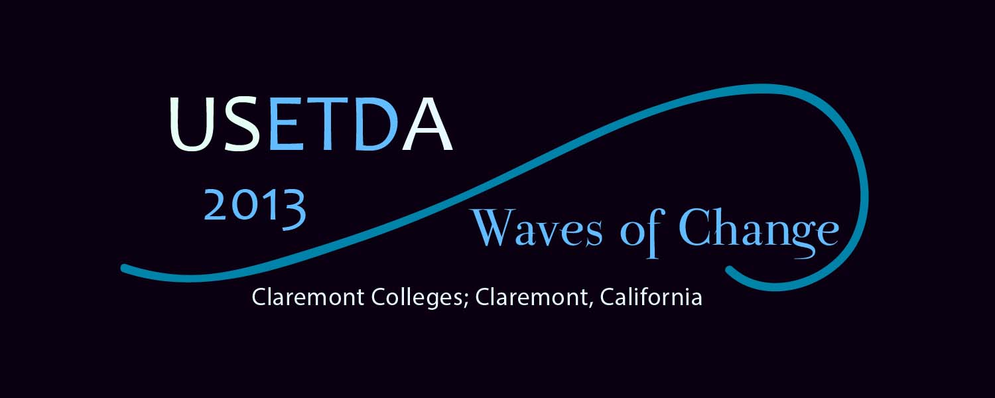
Sponsorship Opportunities
The United States Electronic Thesis and Dissertation Association (USETDA) has announced its 3rd annual conference Waves of Change: Oceans of Opportunity to be held July 24-26, 2013, in Claremont, California. USETDA 2013 is for professionals from graduate schools, libraries, academic computing and anyone else working with electronic theses and dissertations. Our goal is to offer relevant, practice-oriented content to support ETD professionals, advance ETD operations and efficiencies, and encourage the formation of state-wide ETD associations in the United States.
Sponsorship Options
The USETDA offers a variety of conference sponsorship options to help support our mission as well as to promote your brands, products and services. You will find the USETDA 2013 Conference sponsorship options and contract listed below, as well as online. Please take a few moments to consider which level of support you could offer and the benefits we provide. Responses to this sponsorship invitation should be sent no later than May 20, 2013.
About USETDA 2013 - Waves of Change: Oceans of Opportunity
Waves of Change: Oceans of Opportunity is the national conference for ETD professionals from all areas: graduate schools, libraries, and information technology specialists. Our focus is on relevant and current issues with an emphasis on sharing practice-based resources from around the U.S. We anticipate at least 150 people will attend, with most constituents being from the United States. In 2012, we had just over 100 participants attend and had several corporate and non-profit sponsors, including colleges and universities, institutional repository and archival system providers, digital technology applications companies, bookbinders and other library related services. Part of the conference is the ETD Technology Fair, where vendors can set up exhibits and interact with our audience. Additionally there are opportunities to participate in the conference during plenary and breakout sessions as well as through advertising and distribution of your promotional materials at the venue and online. We offer a variety of accommodations to suit your promotional needs. Waves of Change will be held at the Claremont Colleges in beautiful Claremont, California.
USETDA 2013 presentation topics will include:
- Services and outreach to enhance ETD development
- Supporting ETDs with Library services and information instruction
- ETDs and Ethics, Security & Quality
- Centralized and Decentralized submission processes
- Intellectual Property, Copyright, Patents and Tech Transfer
- Developing and implementing ETD Policies and Procedures
- ETD Innovation and Exploration
- File-types and Formatting, including issues surrounding non-traditional formats
- Publishing, Research and Data curation
- Nuts and bolts of ETD management including case studies of workflow and ingest models
- Retroactive digitization and ETD migration/harvesting
- Undergraduate and other student scholarship
Waves of Change: Oceans of Opportunity is a fantastic venue for you to reach out to your constituents. Please consider showing your support by sponsoring this important event.
Contact Persons:
John H. Hagen, Executive Officer and
Angela McCutcheon, Ex Officio Officer
www.usetda.org

USETDA 2013 Conference Resources:
- USETDA 2013 Conference Information http://www.usetda.org/?page_id=1591
- Download USETDA 2013 Sponsorship Contract (pdf)
- USETDA 2013 Conference Registration / Sponsorship Payment http://usetda2013.eventbrite.com

USETDA 2013 Conference Sponsorship Contract

Questions?

Contact John Hagen at john.hagen@renaissance-scholar.com / (304) 241-4677

SPONSORSHIP CONTRACT between USETDA 2013, U.S. National Conference on Electronic Theses and Dissertations and
Sponsoring Organization’s Name & Address

$

The sponsor brings to the U.S. National Conference on Electronic Theses and Dissertations, USETDA 2013, a contribution of

U.S. Dollars, corresponding to the following sponsorship level:

Platinum Sponsor $5,000
- Logo depicted on the front cover of the Conference program
- Mention in all conference literature as a Major sponsor
- Logo displayed on the homepage of USETDA 2013 Web site*
- One full-page color advertisement in the Conference Program (camera ready, 7.5 inches wide by 10 inches high)
- Three free complimentary conference registrations for representatives
- Full-table display in the conference exhibition area
- Speaking opportunity during plenary session (20 minutes)
- Welcome address at a conference reception
- Opportunity to include leaflets in conference delegate packs

Gold Sponsor $2,000 (vendor)
- Logo depicted in the Conference program
- Mention in all Conference literature as an Associated Sponsor
- Logo displayed on USETDA Web site*
- Half-page color advertisement in the Conference Program (camera ready, 7.5 inches wide by 5 inches high)
- Full-table display in the conference exhibition area
- Speaking opportunity during breakout sessions (60 minutes)
- Two free complimentary conference registration for representatives
- Opportunity to include leaflets in conference delegate packs

Gold Sponsor $2,000 (university / non-vendor)
- Logo depicted in the Conference program
- Mention in all Conference literature as an Associated Sponsor
- Logo displayed on USETDA Web site*
- Half-page color advertisement in the Conference Program (camera ready, 7.5 inches wide by 5 inches high)
- Speaking opportunity during plenary session (10 minutes)
- Two free complimentary conference registration for representatives
- Opportunity to include leaflets in conference delegate packs

Silver Sponsor $1,000 (vendor)
- Logo depicted in the Conference program
- Mention in all Conference literature as an Affiliated Sponsor
- Logo displayed on USETDA Conference Web site*
- Quarter-page color advertisement in the Conference Program (camera ready, 3.75 inches wide by 5 inches high)
- Half-table display in the conference exhibition area
- Speaking opportunity during vendor breakout session (10 minutes)
- One free complimentary conference registration for a representative

Silver Sponsor $1,000 (university / non-vendor)
- Logo depicted in the Conference program
- Mention in all Conference literature as an Affiliated Sponsor
- Logo displayed on USETDA Conference Web site*
- Quarter-page color advertisement in the Conference Program (camera ready, 3.75 inches wide by 5 inches high)
- Speaking opportunity during plenary session (5 minutes)
- One free complimentary conference registration for a representative

Bronze Sponsor $750
- Logo depicted in the Conference program
- Mention in all Conference literature as an Affiliated Sponsor
- Logo displayed on USETDA Conference Web site*
- Quarter-page color advertisement in the Conference Program (camera ready, 3.75 inches wide by 5 inches high)

Conference Admission Rates
- Members: $149 early-bird admission ($199 after May 13, 2013)
- Non-Members: $169 early-bird admission ($219 after May 13, 2013)

* Indicates the website will stay online after the event.

Sponsorship Payment Processing Instructions:

This contract document will serve as the invoice for your sponsorship. Please complete, sign, scan/email or fax to return this contract to John Hagen, USETDA Executive Officer. Payment may be made by check made payable to USETDA; include a copy of this contract with your check remittance. For online registration and credit card payments visit http://www.usetda.org/.

USETDA is a national non-profit charitable organization, founded in 2009.

USETDA FEIN: 45-2743803

USETDA Conference Sponsorship Contact Information:

USETDA

c/o John H. Hagen / Renaissance Scholarly Communications

1121 Louise Avenue

Morgantown, WV 26505

Phone/Fax: (304) 241-4677

Email: john.hagen@renaissance-scholar.com

In return sponsorship, USETDA 2013 will give the sponsor the benefits associated with the sponsorship level or negotiated benefits as noted.

 | Sponsor Representative | USETDA Representative

Name

Title

Signature

Date

USETDA – United States Electronic Thesis & Dissertation Association

c/o Renaissance Scholarly Communications

Morgantown, WV • Phone/Fax: (304) 241-4677

www.usetda.org/

