USETDA 2012 Conference Sponsorship Portfolio
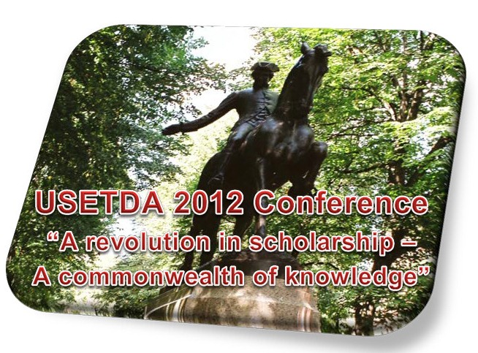
Join the United States Electronic Thesis and Dissertation Association June 13-15, 2012, near downtown Boston for our second annual conference!
About USETDA
The USETDA is a national non-profit organization which supports the electronic publishing of master’s theses and doctoral dissertations in institutional repositories as well as promotes open access initiatives in scholarly communications at colleges and universities in the U.S. The mission of USETDA is to provide information on best practices, develop and disseminate important information on ETD initiatives, support the development of state-wide ETD associations, bring ETD professionals together at the local level to network and improve ETD operations, educate and make others aware of ETD issues, and support the expansion of the NDLTD and other international ETD initiatives.
About USETDA 2012
The USETDA 2012 Conference is designed for ETD professionals from graduate schools, libraries, information technology specialists and others who work with ETDs or ETD programs. Our focus will be on relevant and current ETD issues with an emphasis on sharing practice-based resources from around the U.S. We anticipate at least 150 delegates will attend this year’s conference, mostly from the U.S., but also from Canada and beyond. We received just over 100 delegates for our inaugural conference in 2011 represented by 75 organizations and agencies, with the support of over a dozen corporate and non-profit sponsors, including colleges and universities, institutional repository and archival system providers, digital technology applications companies, bookbinders and other library related services. One of the popular events we host each year is the ETD Technology Fair, where vendors can set up exhibits and interact with our audience. Additionally there are opportunities to participate in the conference during plenary and breakout sessions as well as through advertising and distribution of your promotional materials at the venue and online. We offer a variety of accommodations to suit your promotional needs.
USETDA’s 2012 Conference will be held at the Boston Marriott Quincy Hotel in Quincy (Boston area), Massachusetts. The conference rate is $149/night single/double plus tax. To receive this rate, conference attendees must book before May 22, 2012. All meetings will take place at the conference hotel.
USETDA 2012 Conference Theme
The USETDA 2012 Conference theme is “A Revolution in Scholarship – A Commonwealth of Knowledge” – relevant to Boston’s regional history. Conference participants will have the opportunity to submit proposals for presentation; attend pre-conference workshops; learn best practices for copyright, ETD operations and more; and network with colleagues and vendors from around the nation. The Call for Proposals will be open from January 17 – February 17, 2012.
USETDA 2012 presentation topics will include:
- A Revolution in Scholarship through ETDs Software use, such as Adobe Acrobat, Microsoft Word, and LaTeX tools and tips; student training using podcasts, workshops, etc.; and, ETD research or operationalization of research to enhance the ETD profession
- Promoting a Commonwealth of Knowledge
  - Retrospective digitization approaches; copyright, plagiarism and Fair Use; preservation; Open Access; and, creative commons licensing
- Revolutionizing ETD Operations
  - Sharing of best practices; efficiencies, cost savings, and productivity; cataloging and reviewing practices; ETD workflows; IR/ETD workflow management software; use of social media for communication; and, new and innovative tools and practices
- Starting a Revolution: ETD Initiatives
  - Centralized/decentralized ETD processing; starting-up ETD programs
- Building a Commonwealth of ETD Professionals
  - Leadership and management training and skills development; use of assessment tools for ETD professionals and managers; mentoring for ETD professionals; and, USETDA state-wide associations
Make plans now to experience the “Revolution in Scholarship” next June 13 – 15, 2012 in the heart of Boston!
Sponsorship Options
The USETDA offers a variety of conference sponsorship options to help support our mission as well as to promote your brands, products and services. You will find the USETDA 2012 Conference Sponsorship options and contract online. Please take a few moments to consider which level of support you could offer and the benefits we provide. Responses to this sponsorship invitation should be sent no later than Monday, February 27, 2012.
Should you have any questions, feel free to contact me or any of our Board members.
Sincerely,
John H. Hagen, Executive Officer and
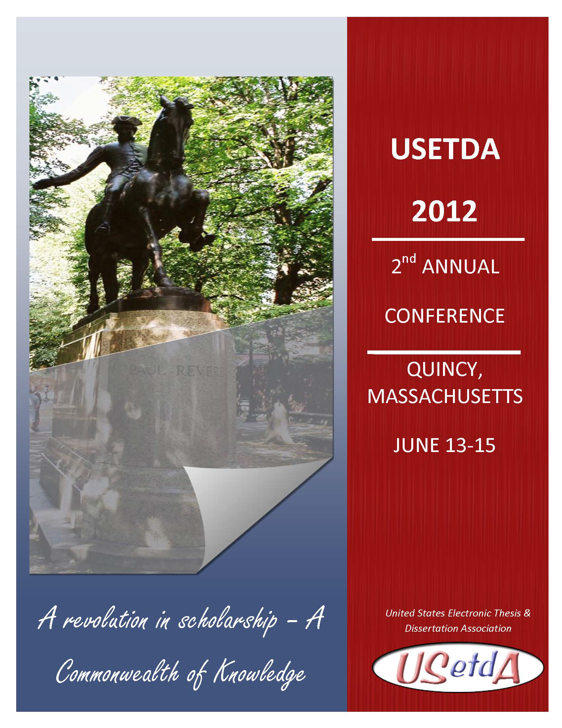Angela McCutcheon, Executive Officer
USETDA Board of Directors
www.usetda.org

USETDA 2012 Conference Resources:

USETDA 2012 Conference
http://www.usetda.org/?page_id=722

Download this USETDA 2012 Sponsorship Portfolio and Contract
http://www.usetda.org/?page_id=816

USETDA 2012 Conference Registration / Sponsorship Payment
http://www.usetda.org/?page_id=818

USETDA 2012 Conference Sponsorship Contract

Questions? Contact Angela McCutcheon at mccutcha@ohio.edu / (740) 597-2599

or John Hagen at John.Henry.Hagen@gmail.com / (304) 290-2516

SPONSORSHIP CONTRACT between USETDA 2012, U.S. National Conference on Electronic Theses and Dissertations and
Sponsoring Organization’s Name & Address

$

The sponsor brings to the U.S. National Conference on Electronic Theses and Dissertations, USETDA 2012, a contribution of

U.S. Dollars, corresponding to the following sponsorship level:

Platinum Sponsor $5,000
- Logo depicted on the front cover of the Conference program
- Mention in all conference literature as a Major sponsor
- Logo displayed on the homepage of USETDA 2011 Web site*
- One full-page color advertisement in the Conference Program (camera ready, 7.5 inches wide by 10 inches high)
- Three free complimentary conference registrations for representatives
- Full-table display in the conference exhibition area
- Speaking opportunity during plenary session (20 minutes)
- Welcome address at a conference reception
- Opportunity to include leaflets in conference delegate packs

Gold Sponsor $2,000 (vendor)
- Logo depicted in the Conference program
- Mention in all Conference literature as an Associated Sponsor
- Logo displayed on USETDA Web site*
- Half-page color advertisement in the Conference Program (camera ready, 7.5 inches wide by 5 inches high)
- Full-table display in the conference exhibition area
- Speaking opportunity during breakout sessions (60 minutes)
- Two free complimentary conference registration for representatives
- Opportunity to include leaflets in conference delegate packs

Gold Sponsor $2,000 (university / non-vendor)
- Logo depicted in the Conference program
- Mention in all Conference literature as an Associated Sponsor
- Logo displayed on USETDA Web site*
- Half-page color advertisement in the Conference Program (camera ready, 7.5 inches wide by 5 inches high)
- Speaking opportunity during plenary session (10 minutes)
- Two free complimentary conference registration for representatives
- Opportunity to include leaflets in conference delegate packs

Silver Sponsor $1,000 (vendor)
- Logo depicted in the Conference program
- Mention in all Conference literature as an Affiliated Sponsor
- Logo displayed on USETDA Conference Web site*
- Quarter-page color advertisement in the Conference Program (camera ready, 3.75 inches wide by 5 inches high)
- Half-table display in the conference exhibition area
- Speaking opportunity during vendor breakout session (10 minutes)
- One free complimentary conference registration for a representative

Silver Sponsor $1,000 (university / non-vendor)
- Logo depicted in the Conference program
- Mention in all Conference literature as an Affiliated Sponsor
- Logo displayed on USETDA Conference Web site*
- Quarter-page color advertisement in the Conference Program (camera ready, 3.75 inches wide by 5 inches high)
- Speaking opportunity during plenary session (5 minutes)
- One free complimentary conference registration for a representative

Bronze Sponsor $750
- Logo depicted in the Conference program
- Mention in all Conference literature as an Affiliated Sponsor
- Logo displayed on USETDA Conference Web site*
- Quarter-page color advertisement in the Conference Program (camera ready, 3.75 inches wide by 5 inches high)

Conference Admission Rates
- Members: $129 early-bird admission ($179 after May 14)
- Non-Members: $149 early-bird admission ($199 after May 14)

* Indicates the website will stay online after the event.

Sponsorship Payment Processing Instructions:

This contract document will serve as the invoice for your sponsorship. Please complete, sign, scan/email or fax to return this contract to John Hagen, USETDA Executive Officer. Payment may be made by check made payable to USETDA; include a copy of this contract with your check remittance. For online registration and credit card payments visit http://www.usetda.org/.

USETDA is a national non-profit charitable organization, founded in 2009.

USETDA FEIN: 45-2743803

USETDA Conference Sponsorship Contact Information:

USETDA c/o Angela McCutcheon

Ohio University Graduate College

220G Research & Technology Center

Athens, OH 45701

Phone: (740) 597-2599 • Fax: (740) 593-4625

Email: mccutcha@ohio.edu

In return sponsorship, USETDA 2012 will give the sponsor the benefits associated with the sponsorship level or negotiated benefits as noted.

 | Sponsor Representative | USETDA Representative

Name

Title

Signature

Date

USETDA – United States Electronic Thesis & Dissertation Association

Ohio University Graduate College 220G Research & Technology Center

Athens, OH 45701 • Phone: (740) 597-2599 • Fax: (740) 593-4625

http://www.usetda.org/

